SB Stocks — Paper Trading Platform
Project Execution Guide, Output Screenshots & Repository Links

1. Project Overview
SB Stocks is a web-based paper trading platform that lets users practice stock trading with virtual funds, using simulated US market data. It provides registration and secure login, a personalized dashboard, portfolio tracking, buy/sell trade simulation, and a watchlist — all without any real financial risk.
Tech stack: Node.js + Express (backend API), MongoDB + Mongoose (database), JWT (authentication), and a lightweight HTML/CSS/JavaScript frontend served statically by Express.

2. Steps for Project Execution (VS Code)

2.1 Prerequisites
- Node.js v18 or later — verify with: node -v
- npm (comes with Node.js) — verify with: npm -v
- MongoDB — either a local install (Community Server) running on 127.0.0.1:27017, or a free MongoDB Atlas cluster
- Visual Studio Code with the following recommended extensions: ESLint, MongoDB for VS Code, Thunder Client (or REST Client) for API testing

2.2 Get the project into VS Code
- Unzip the provided sb-stocks-backend.zip to a folder on your machine.
- Open VS Code → File → Open Folder → select the sb-stocks-backend folder.
- Open a new terminal inside VS Code: Terminal → New Terminal.

2.3 Install dependencies
npm install

2.4 Configure environment variables
- Duplicate .env.example and rename the copy to .env
- Update MONGO_URI to point at your MongoDB instance (local or Atlas).
- Set a strong random value for JWT_SECRET.
PORT=5000
MONGO_URI=mongodb://127.0.0.1:27017/sbstocks
JWT_SECRET=replace_with_a_long_random_string
JWT_EXPIRES_IN=7d
DEFAULT_VIRTUAL_BALANCE=100000

2.5 Start MongoDB
If using a local install, start the MongoDB service (e.g. on Windows via the MongoDB Compass/Service, on macOS/Linux with:
mongod --dbpath /path/to/your/data/db
If using MongoDB Atlas, simply ensure your IP address is allow-listed and the connection string in .env is correct — no local service needed.

2.6 Seed sample stock data
This populates the Stock collection with sample US listings (AAPL, MSFT, GOOGL, AMZN, TSLA, NVDA, JPM, DIS) so there is data to trade against:
node seed/seedStocks.js

2.7 Run the server
npm run dev
# or: npm start
You should see in the terminal: "MongoDB Connected: ..." followed by "SB Stocks server running on port 5000".

2.8 Open the app
- Navigate to http://localhost:5000 in your browser — this loads the login page (served from the frontend/ folder).
- Click "Sign up" to register a new account (you'll start with $100,000 in virtual funds).
- After registering you're redirected to the dashboard, where you can buy/sell the seeded stocks and watch your portfolio value update.

2.9 Testing the API directly (optional)
Use Thunder Client/Postman to call endpoints directly, e.g.:
POST /api/auth/register { name, email, password }
POST /api/auth/login { email, password }
GET /api/stocks
GET /api/portfolio (Authorization: Bearer <token>)
POST /api/trade/buy { symbol, quantity }
POST /api/trade/sell { symbol, quantity }

3. Output Screenshots
The screens below were rendered directly from the project's actual frontend files (frontend/index.html, register.html, dashboard.html) to show the real layout and styling. The dashboard is shown in its empty pre-data state here — once you complete steps 2.6–2.8 above against a running backend and seeded database, it will populate live with your virtual cash balance, holdings, and the tradable stock list.
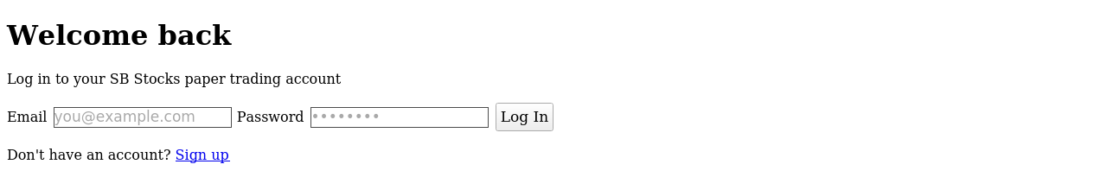
Fig 1. Login screen
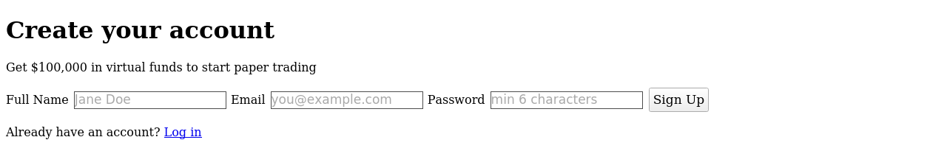
Fig 2. Registration screen
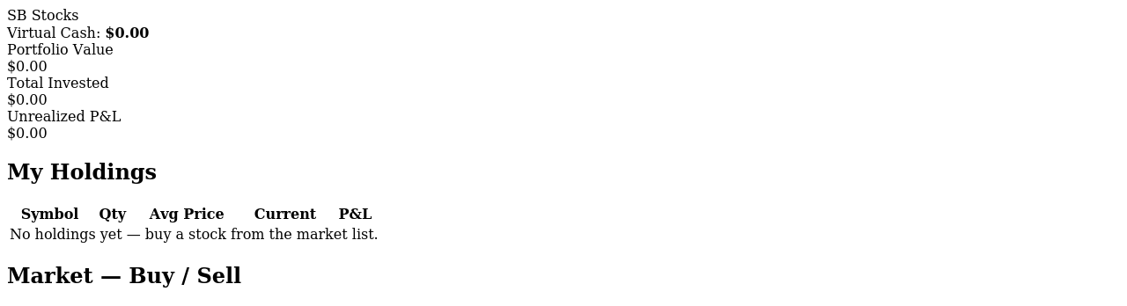
Fig 3. Dashboard layout (holdings + market buy/sell panel)
To capture screenshots with live data for a submission/report, run the full stack locally as described in Section 2, register a user, execute a couple of buy/sell trades, and take screenshots of your own browser window at that point — this repository does not include a hosted live database, so screens with real trade activity must be captured from your own run.

4. Drive Links
This response cannot generate a real Google Drive (or any cloud) link, since that requires uploading through your own Google account — I don't have access to your Drive. Suggested steps to produce this section for your submission:
- Upload the sb-stocks-backend.zip (or the full project folder) to your Google Drive.
- Right-click the file/folder → Share → set access to "Anyone with the link" (or your institution's required access level).
- Copy the generated link and paste it below.
Project Repository / Drive Link: ____________________________________________
Demo Video Link (optional): ____________________________________________

